Full Details for Lot 1306
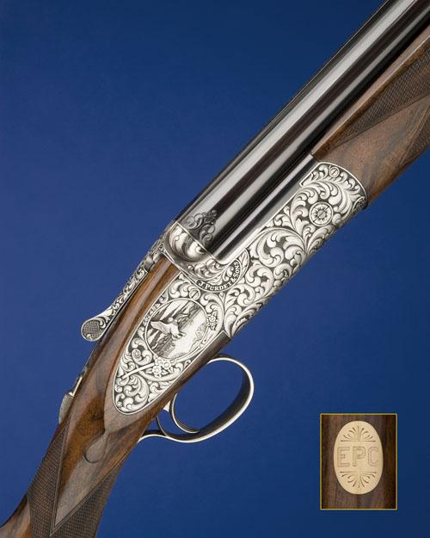
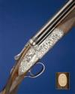 | 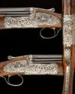 |  | 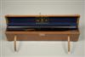
Sale 1023 Lot 1306
J. PURDEY & SONS
A UNIQUE, DELUXE TALLETT-ENGRAVED 12-BORE SINGLE-TRIGGER OVER AND UNDER SIDELOCK EJECTOR, serial no. 29840,
28in. nitro barrels with matt game rib and side-ribs, scroll engraved at the breech end, over barrel engraved 'J. PURDEY & SONS. AUDLEY HOUSE. SOUTH AUDLEY STREET. LONDON. ENGLAND.', 2 3/4in. chambers, bored approx. 1/4 and 1/2 choke, hold-open toplever, automatic safety, non-selective single trigger, rolled-edge triggerguard, the action, lockplates and furniture deeply chiselled with bold acanthus and floral motifs on a matt background, the lockplates with vignettes of English partridge and mallard in flight and signed 'WEZ TALLETT', the underside with a pheasant, the side-bolsters carved in relief with the makers name, the fore-end iron decorated en suite, bright finish overall, 14 3/4in. highly-figured stock with Prince of Wales grip and carved steel pistolgrip-cap, gold escutcheon engraved 'E.P.C.', weight 7lb. 7oz., in its lightweight leather motor case with accessories. The makers have kindly confirmed that the gun was completed in May 2003.
Estimate £40,000-60,000

