Full Details for Lot 1304
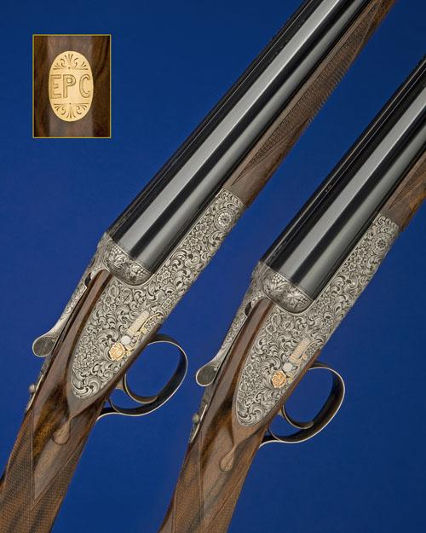
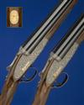 | 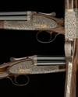 | 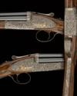 | 
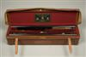
Sale 1023 Lot 1304
J. PURDEY & SONS
AN EXCEPTIONAL PAIR OF UNUSED, COGGAN-ENGRAVED, 12-BORE ROUND-BODIED SINGLE-TRIGGER SELF-OPENING SIDELOCK EJECTORS, serial no. 30117 / 8,
28in. nitro chopperlump barrels, ribs gold-inlaid '1' and '2', tubes engraved 'J. PURDEY & SONS. LONDON. ENGLAND.', 2 3/4in. chambers, bored approx. 1/4 and 1/2 choke, self-opening actions with rounded bars, pinless lockplates, automatic safeties with gold-inlaid 'SAFE' details in gothic script, gold-inlaid cocking-indicators, non-selective single-triggers, the fences deeply carved in relief with grape and vine motifs, the actions, lockplates and furniture fully engraved with bold arabesques interspersed with floral bouquets, all on a matt background, the lockplates relief engraved and gold-inlaid with a single English rose, the makers name gold-inlaid in gothic script within a scrolled ribbon, the fore-end irons decorated en-suite and also gold-inlaid 'Purdey' in gothic script, the triggerplates signed 'S. COGGAN', bright finish overall, 14 1/2in. highly-figured stocks, gold escutcheons engraved 'E.P.C.', weight 6lb. 12oz., in their lightweight leather motor case with accessories and canvas outer. The makers have kindly confirmed that the guns were completed in November 2004
Estimate £70,000-90,000

