Full Details for Lot 1305
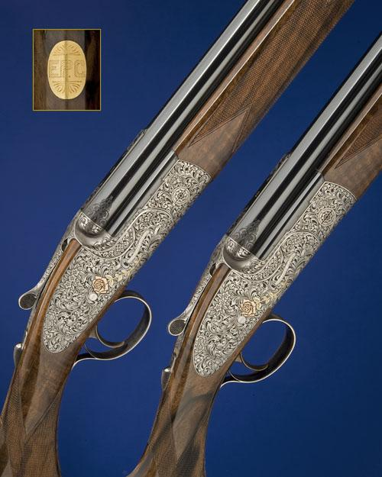
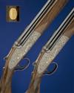 | 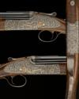 |  | 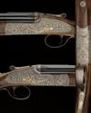
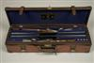
Sale 1023 Lot 1305
J. PURDEY & SONS
A MAGNIFICENT PAIR OF DELUXE COGGAN-ENGRAVED 20-BORE SINGLE-TRIGGER OVER AND UNDER SIDELOCK EJECTORS, serial no. 30263 / 4,
29in. ribless nitro barrels, the breech ends with bold scroll engraving and gold-inlaid '1' and '2', over barrels engraved 'J. PURDEY & SONS. LONDON. ENGLAND.', 2 3/4in. chambers, bored approx. 1/2 and full choke, hold-open toplevers, automatic safeties with gold-inlaid 'SAFE' details, rounded bars, gold-inlaid cocking-indicators, non-selective single-triggers, rolled-edge triggerguards, the actions, lockplates and furniture fully engraved with bold arabesques interspersed with floral bouquets, all on a matt background, the lockplates relief engraved and gold-inlaid in three colour gold with a single English rose, the makers name gold-inlaid in gothic script within a scrolled ribbon, the fore-end irons decorated en-suite and also gold-inlaid 'Purdey' in gothic script, the triggerplates signed 'S. COGGAN', bright finish overall, 14 1/2in. highly-figured pistolgrip stocks with carved steel pistolgrip-caps, gold escutcheons engraved 'E.P.C.', weight 6lb. 7oz., in their fitted reptilian skin motor case with accessories and canvas outer. The makers have kindly confirmed that the guns were completed in April 2007.
Estimate £80,000-120,000

