Full Details for Lot 1300
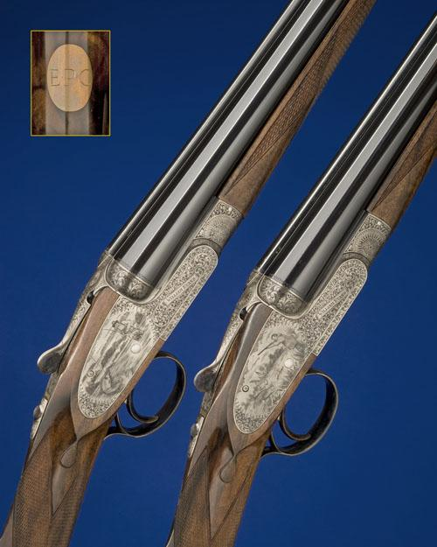
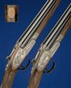 | 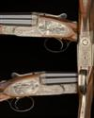 | 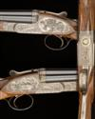 | 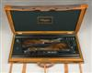
Sale 1023 Lot 1300
WILLIAM EVANS
A FINE AND UNUSED PAIR OF MARCUS HUNT-ENGRAVED 20-BORE SINGLE-TRIGGER SELF-OPENING SIDELOCK EJECTORS, serial no. 20060 / 1,
28in. nitro chopperlump barrels, ribs engraved 'WILLIAM EVANS LIMITED. 67A, ST. JAMES'S STREET. LONDON. S.W.1.' and gold-inlaid '1' and '2', 2 3/4in. chambers, bored approx. imp cyl and 1/4 choke, actions incorporating Holland & Holland type self-opening systems, semi-selective single-triggers, rolled-edge triggerguards, automatic safeties with gold-inlaid 'SAFE' details, gold-inlaid cocking-indicators, the actions, lockplates and furniture deeply engraved with best bold acanthus scrolls on a matt background, the pinless lockplates very finely engraved with vignettes of Eric Clapton; gun No.1 with him sat against a tree playing an acoustic guitar (left side) and catching a trout on the fly (right); gun No.2 with him having cast a fly (left) and partridge shooting (right), all signed 'M.A. Hunt', the undersides set with colour-hardened roundels, gold-inlaid with the monogram 'W.E.', bright finish overall, 14 5/8in. highly-figured stocks, weight 6lb. 6oz., with gold escutcheons bearing the initials 'E.P.C.' in their brass-cornered oak and leather case with full complement of William Evans accessories and canvas and leather outer cover. The makers have kindly confirmed that the guns were completed mid 2007.
Estimate £40,000-60,000

