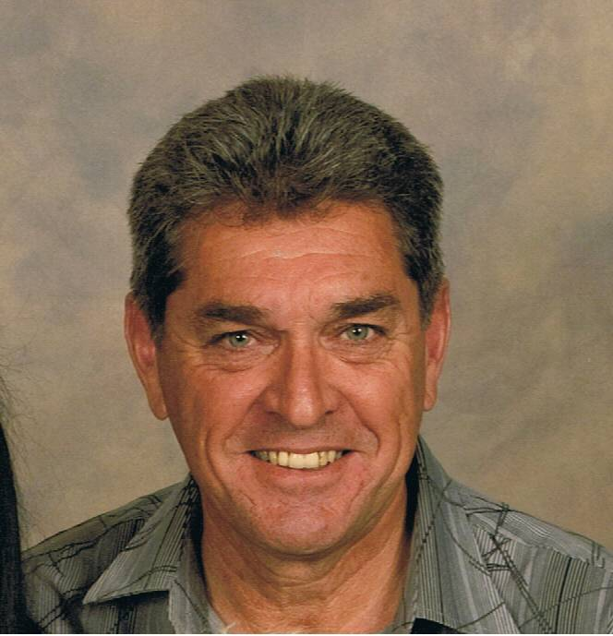
Representing all Outdoor Recreational and Sporting Activities

Open Letter to all Firearms Owners, Fishing Sports and Outdoors Recreation Enthusiasts in South Australia

This is to all licensed firearms owner or participants in fishing or other outdoor recreational activities.

You will be aware that on the 20th of March we have a State Election. This is the day on which, once in every four years, you can have your say as a South Australian by casting your vote to elect your representatives in both Houses of Parliament. It is an important day that will determine our future and the way of life for which we all strive. Your vote is precious - something that many of us consider is the most important thing next to our families, our friends, our health, our chosen interests, our statutory rights and our implied freedoms. We often take these things for granted - until either their removal is threatened or we become aware that they have been stolen from us by a Government that implements unjust laws, by stealth, by means of bypassing our proper Parliamentary processes.

Our freedoms are many and varied and, in most cases, are never missed until we dare question their removal, particularly when the justification for such removal is cited as “the need to protect us all.” Most change is generally thrust upon us by the Government or some other authority in between the day we cast our vote and the day when we are able to do so again. Four years is a long time and if the things that we take for granted are not noticeably changed and we are blinded by new promises that appeal to our ideals and wants, we often tend to complacently vote for the authority we accept or the one that best appeals to the ideals and wants that we strive to achieve. From the Government that we elect, we expect that it will serve us and foster our ideals (not its own agenda) and forthrightly protect those many freedoms and other things that we too often naively take for granted.

As reasonable, free people we do not expect that our Government will improperly take these things from us - whether by act of arrogance, by corruption or deceit, by conspired stealth, by abuse of power or, worse, by abrogating its power and responsibilities to statutory authorities or unelected public servants giving them excessive, unearned & unjust discretionary powers in the absence of proper oversight to prevent a clear disregard for due process and the critical separation of power between law makers and law enforcers. In a democratic, secular society that’s based on common law, equality and a fair go for all, single or minor issues should not determine how we elect Governments. We are entitled to expect that the Government we elect will always consider these principles and implement and adhere to measures that guard and protect our statutory rights and implied freedoms - and in particular when enacting laws that affect our livelihood, interests, property and possessions.

Sadly, these principles have been eroded in the last four years by a tired Government - and in particular by many of our elected members of both our Houses of our Parliament and many of our statutory authorities, by:

- refusing to properly consult in any meaningful way;
- refusing to accept viable and sensible alternatives from those that are the most affected - even when directed in this regard by our Parliamentary Committees and House of Review; and
- allowing bureaucrats to exploit these unjust practices by seeking to bypass the fundamental Parliamentary processes and safeguards,
facilitating this by deceit and abuse of power and due process, the removal of our freedoms and the destruction of the critical principle of separation of powers.

This has happened so blatantly in so many ways and has both disenfranchised and disempowered so many of us that, for the sake of our rights and freedoms going forward, it must be stopped on the 20th of March.

We have seen recent abuses of power and an arrogant disregard of our rights and interests in the form of:

- a denial of our ability to associate freely;
- the seizure of our lawfully acquired property without any compensation by changing Regulations;
- the demise of our inner suburban parklands;
- the ability to gain meaningful recreational access to our National Parks;
- desecration by inaction of our major rivers and waterways and exclusion from our large coastal waters;
- the disposal of our local Heritage Buildings; and
- the abuse of our Judiciary and Law Enforcement agencies, through other means and measures and the misuse of proper process.

Twice in the space of two years - and most recently in January, 2010 - our Firearms Laws have been changed by party politics, under the guise of the changes being “for the good of all”. These laws mean that many of us can now be deprived of our lawfully acquired property without any compensation, without any proper consultation and without access to due process. This has been done largely in the absence of Parliamentary will or desire and has been exploited and implemented by the very authority that’s tasked with the administration of these laws. This has occurred as a result of:

- a complete absence of any meaningful or useful Government oversight;
- the granting (and abuse) of excessive discretionary powers that, both by inference and in practice, have bypassed and trodden upon our rights and freedoms - largely without public notice or understanding; and
- the removal of our ability to seek meaningful redress - other than through a lengthy and costly process that can only be embarked upon by individuals fighting a bureaucracy that’s supported by limitless Government legal and other resources through a judicial system that has itself been hobbled by a lack funding and the disregard of the principles of both autonomy and separation of powers.

Sadly, our ability to prevent these abuses from occurring by seeking meaningful debate through the Parliamentary House of review, namely, our Legislative Council, was blunted in an unethical, unprecedented and deceitful manner - after the Regulations were specifically disallowed - after our Parliament had risen for the Christmas break and not to be returned until after the election. This was done by a Government that’s thirsty for power and arrogant in the manner in which it exercises the powers entrusted to it and the means it seeks to keep them. Specifically, these new Firearms Laws and the authority’s discretionary powers in implementing them, can now result in the removal of our property with no consultation, no compensation and no right of any meaningful redress. Similarly, new fishing regulations that remove the ability of the normal law abiding fishers from going about their chosen pastimes means that many tens of thousands of South Australians have lost their ability to fish from many of our jetties and our plentiful marine waters. These and other abuses have occurred during the last four years and, we have been powerless to do anything meaningful about it, until now - and that’s the exercise of our vote on Election Day.

On the 20th March we have an opportunity to vote to correct these abuses - but only you can do so. As a candidate for the Shooters Party nominated for the Legislative Council, I am asking you to give me your precious vote to enable me to represent you and your ideals in the only forum that we have available - the Legislative Council - our Upper House of Parliament - and to seek to correct the above particularised many wrongs. Remember, it’s not just about firearms and fishing and other outdoor recreational activities - it’s also about you as a person and a fair go for all South Australians, our rights, privileges, freedoms and our way of life. If you believe and feel this way then, please, Vote “1” above the line for the “Shooters Party” in the Legislative Council on March 20^{th.}

Our New South Wales colleagues, now known as the “Shooters and Fishers Party”, have achieved this and currently have two members elected to the NSW Legislative Assembly. We CAN do the same. If you are one of the 60,000+ firearm licence holders and/or one of the many tens of thousands of recreational fishers and outdoor enthusiasts in the State of South Australia who is aggrieved in the manner in which your life, your interests and your freedoms have been improperly and unfairly removed your vote CAN AND WILL make a difference. Your vote will help to protect your interests and safeguard the things you value the most. Only YOU can vote to do this. .If elected, I cannot guarantee any immediate outcome as a single voice. However, I can guarantee that I will do my utmost and, to the best of my abilities, use the democratic process with all other likeminded members of both Houses of Parliament so as to correct earlier wrongs and protect the things that we all hold so dearly.

Yours sincerely,
Michael T. Hudson Shooters Party – Candidate Legislative Council

